1. MongoDB is no-sql solution as it follows the opposite concept or philosophy than that sql based databases do.  
   Instead of normalizing data which means storing it, distribute it across multiple tables where every table has a clear schema and then using a lot of relations, instead of doing that, mongodb goes for storing data together in a document.  
   It doesn’t enforce schema on you. If we have multiple documents in the same collection then they can have different structures.   
   This can of course lead to messy data but it’s still your responsibility as a developer to work clean data and to implement a solution that works.  
   But, it gives you a lot of flexibility so you can use mongodb for apps that might still evolve where the exact data requirements are just not set yet.  
   So, you can get started and you can always add data with more info in the same collection.  
   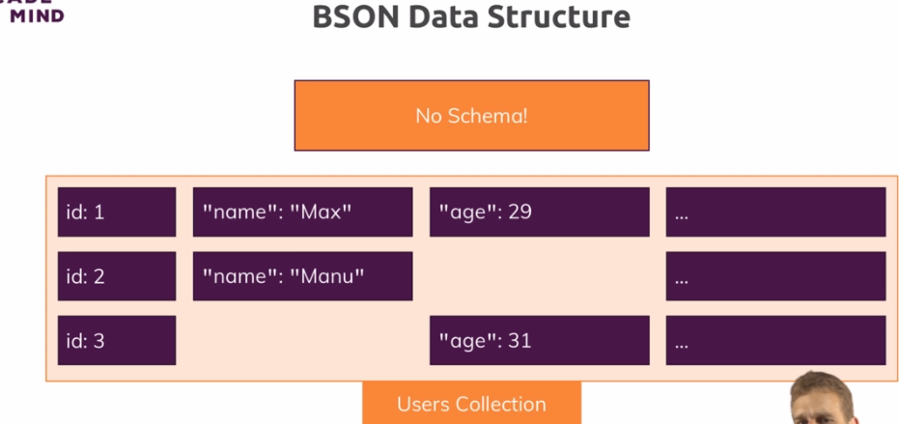
2. You also work with fewer relations. There are some relations. But with these **embedded documents** one core thing of mongodb indeed is that you have fewer collections (tables in SQL) that you connect but instead you store data together and this is where efficiency is derived from. Since data is stored together, so when your app is fetching data, it doesn’t need to reach out to collection A, merge it with Collection B and then with Collection C. Instead it goes to collection A then mongodb has a very efficient querying mechanism behind the scenes so that it can go through all the data very fast when looking for a specific document. It finds the document and it’s done. It doesn’t need to do any merging most of the time.   
   So, this is really where the speed, the performance and flexibility come from and this hopefully speaks for itself that this can be useful when building applications and this is also why noSQL solutions and amongst them most of all mongodb, is super popular for read write heavy applications, applications with a lot of workload, applications that store a lot of data. Let’s say smart devices which send some sensor data every second and also for building an online shop or a blog, mongodb is an amazing solution due to the performance and the flexibility it gives you. 